

**Homework # 4**

**01286121 Computer Programming**

**Software Engineering Program,**

**Department of Computer Engineering,**

**School of Engineering, KMITL**

By

65011693 Soe Moe Htet

No. 1

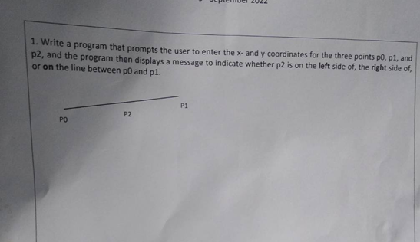

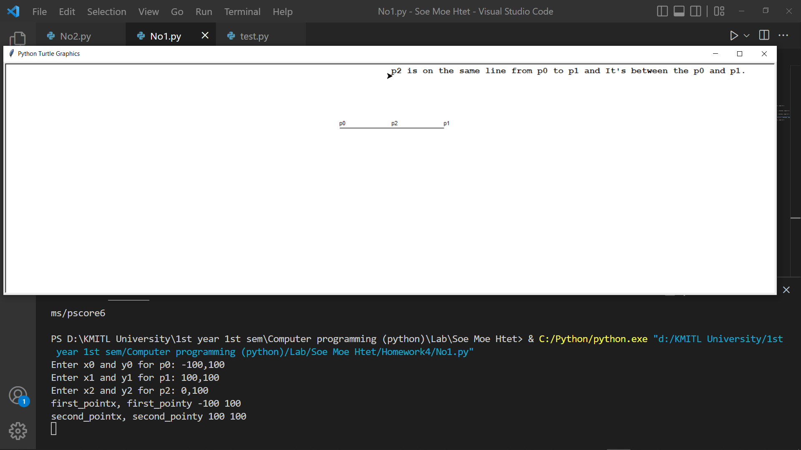

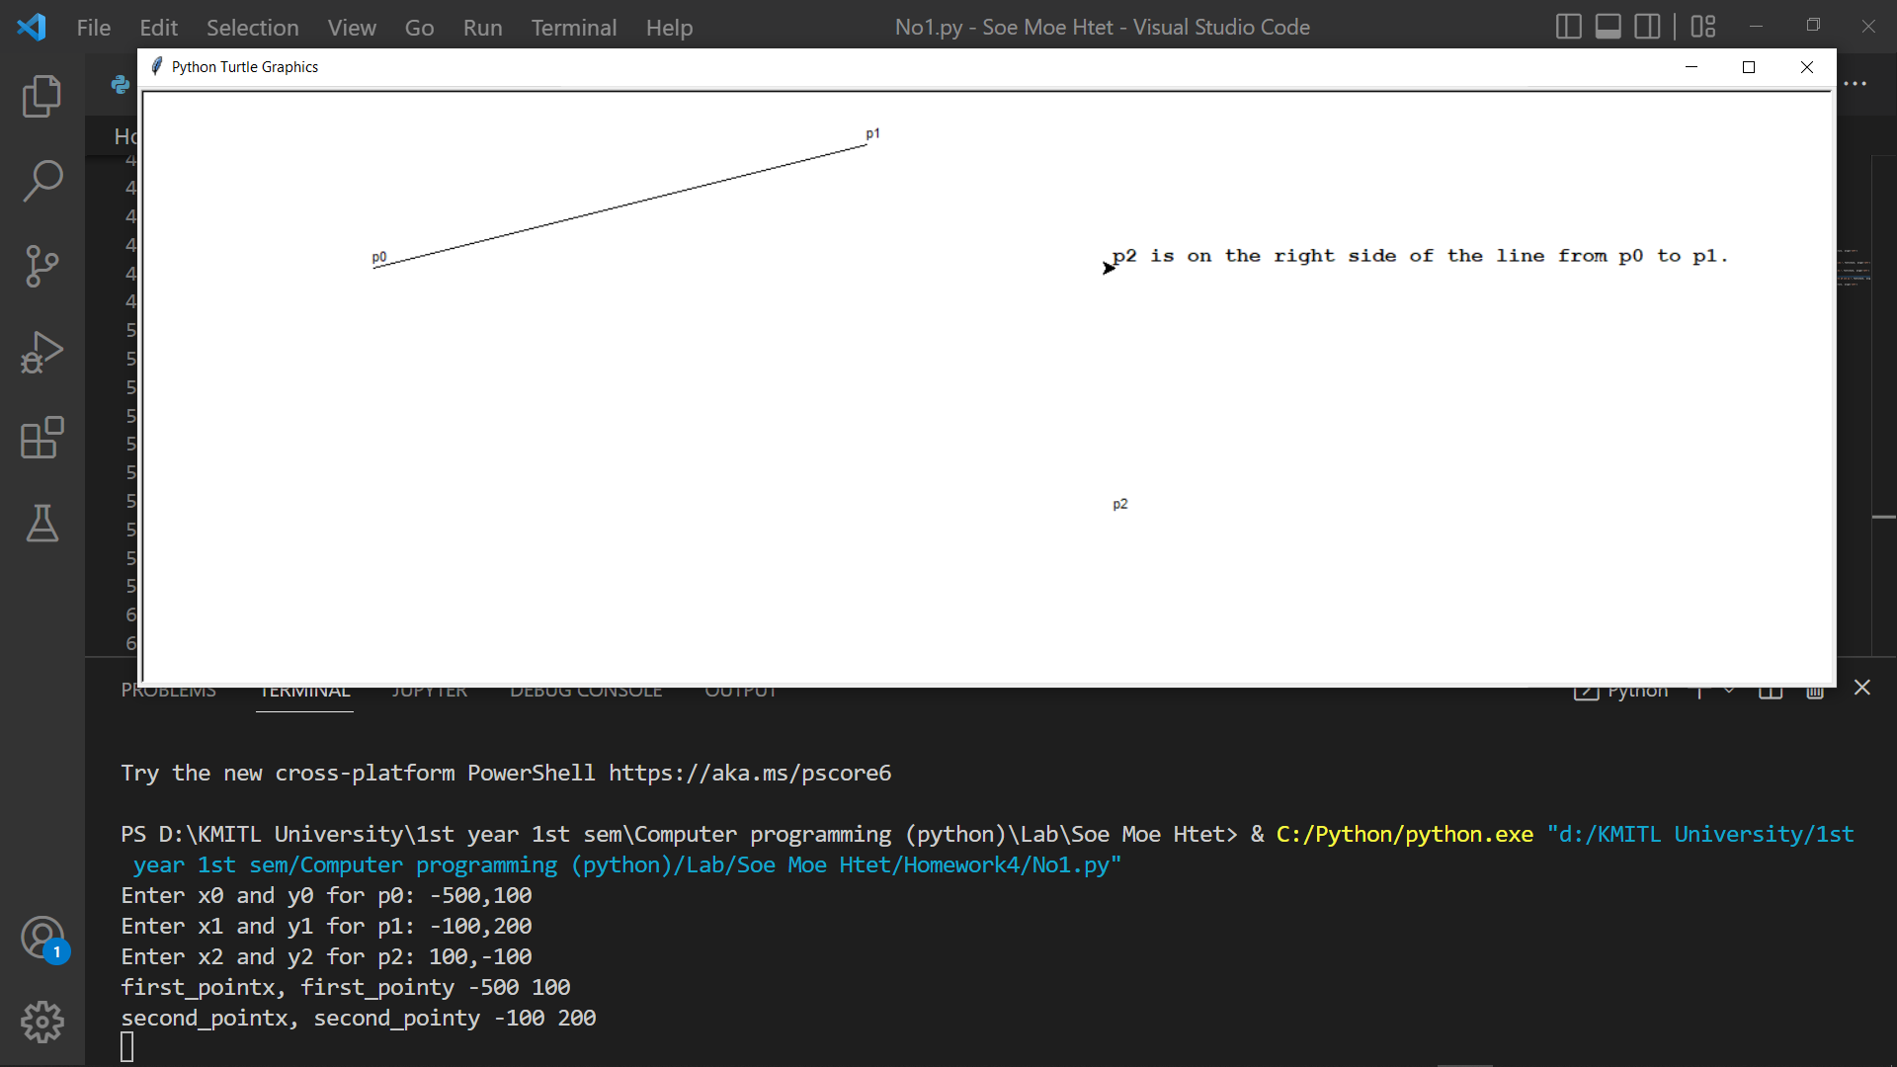

No. 2

